List of Attendees Sign-on Form

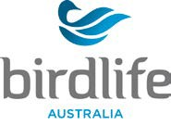

Note:
All participants undertaking a BirdLife Australia activity are required to sign on to be covered by BirdLife
Australia’s insurance policy. Signing on acknowledges you will follow BirdLife Australia’s Policies and Procedures and reasonable directions given by the leader. Participants should only perform activities that are within their experience and ability. Participants also agree to disclose any medical conditions that may be adversely affected while undertaking the activity.

Activity: Location: Leader:

Date:

Signature:

Name | Address | Emergency Contact (name and number | Signature | I have declared any relevant medical condition to the activity leader (yes/no)

