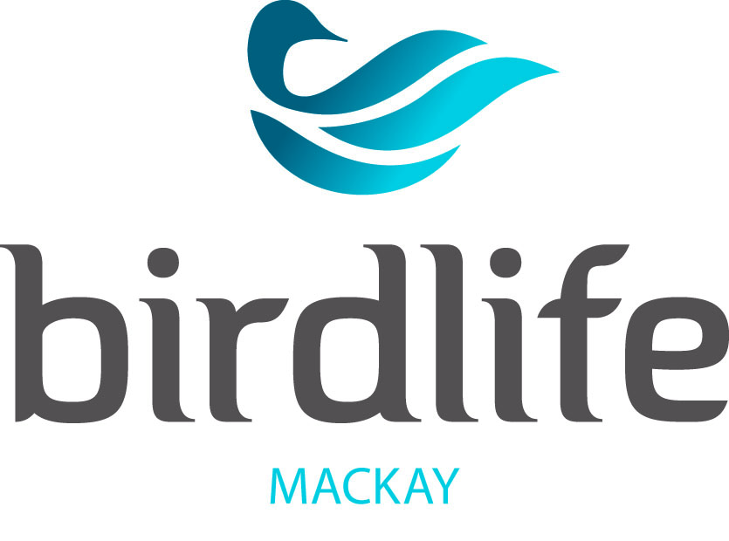
Eungella Bird Week 11-15 Sept 2023
Registration Form
Registrant/s
Name…………………………………………………………………………………………………………………………………………
Address……………………………………………………………………………………………………………………………………..
Phone No/Nos……………………………………………………………………………………………………………………………
Email…………………………………………………………………………………………………………………………………………
Any medical related Dietary Requirements ………………………………………………………………………
Any Medical Conditions We Should Be Aware Of ……………………………………………………………………...
Emergency Contact Name & Ph Number……………………………………………………………………………………
Cost $495 per person
EARLY BIRD cost $445 per person before 30 June 2023
Payable by Electronic Funds Transfer to:
Acc. Name: Birdlife Mackay BSB: 124001 Acc. No. 22301807 Ref: Surname
Non-Refundable Deposit $50 Balance Payable by 1 August 2023
Please Return the Registration Form to: info@shillerimages.com
Package Inclusions:
- Three days/four nights of Eungella Honeyeater Data Collection & Guided Birding
- Welcome Dinner Monday Night
- BBQ Dinner on Tuesday Night
- Bush Morning Teas on Tuesday, Wednesday and Thursday
- Lunch on Tuesday, Wednesday and Thursday
- Group Dinner at ‘The Chalet’ Wednesday Night (excluding drinks)
- Farewell Dinner – Eungella Community Hall
Package Exclusions:
- Transport to and from Eungella
- Participants will be responsible for their own accommodation. Accommodation options are listed on the Supplementary Information Sheet.
- Participants will also be required to self-cater for all breakfasts.
- The Community Hall will be available for participants to prepare meals if required.

