The BirdLife Top End branch is a central forum for community activities centered around the conservation of birds and their habitats in the 'Top End' region of the Northern Territory. The BirdLife Top End branch aligns with the core values of BirdLife Australia to make a real and positive difference for Australia’s birds in the Northern Territory. 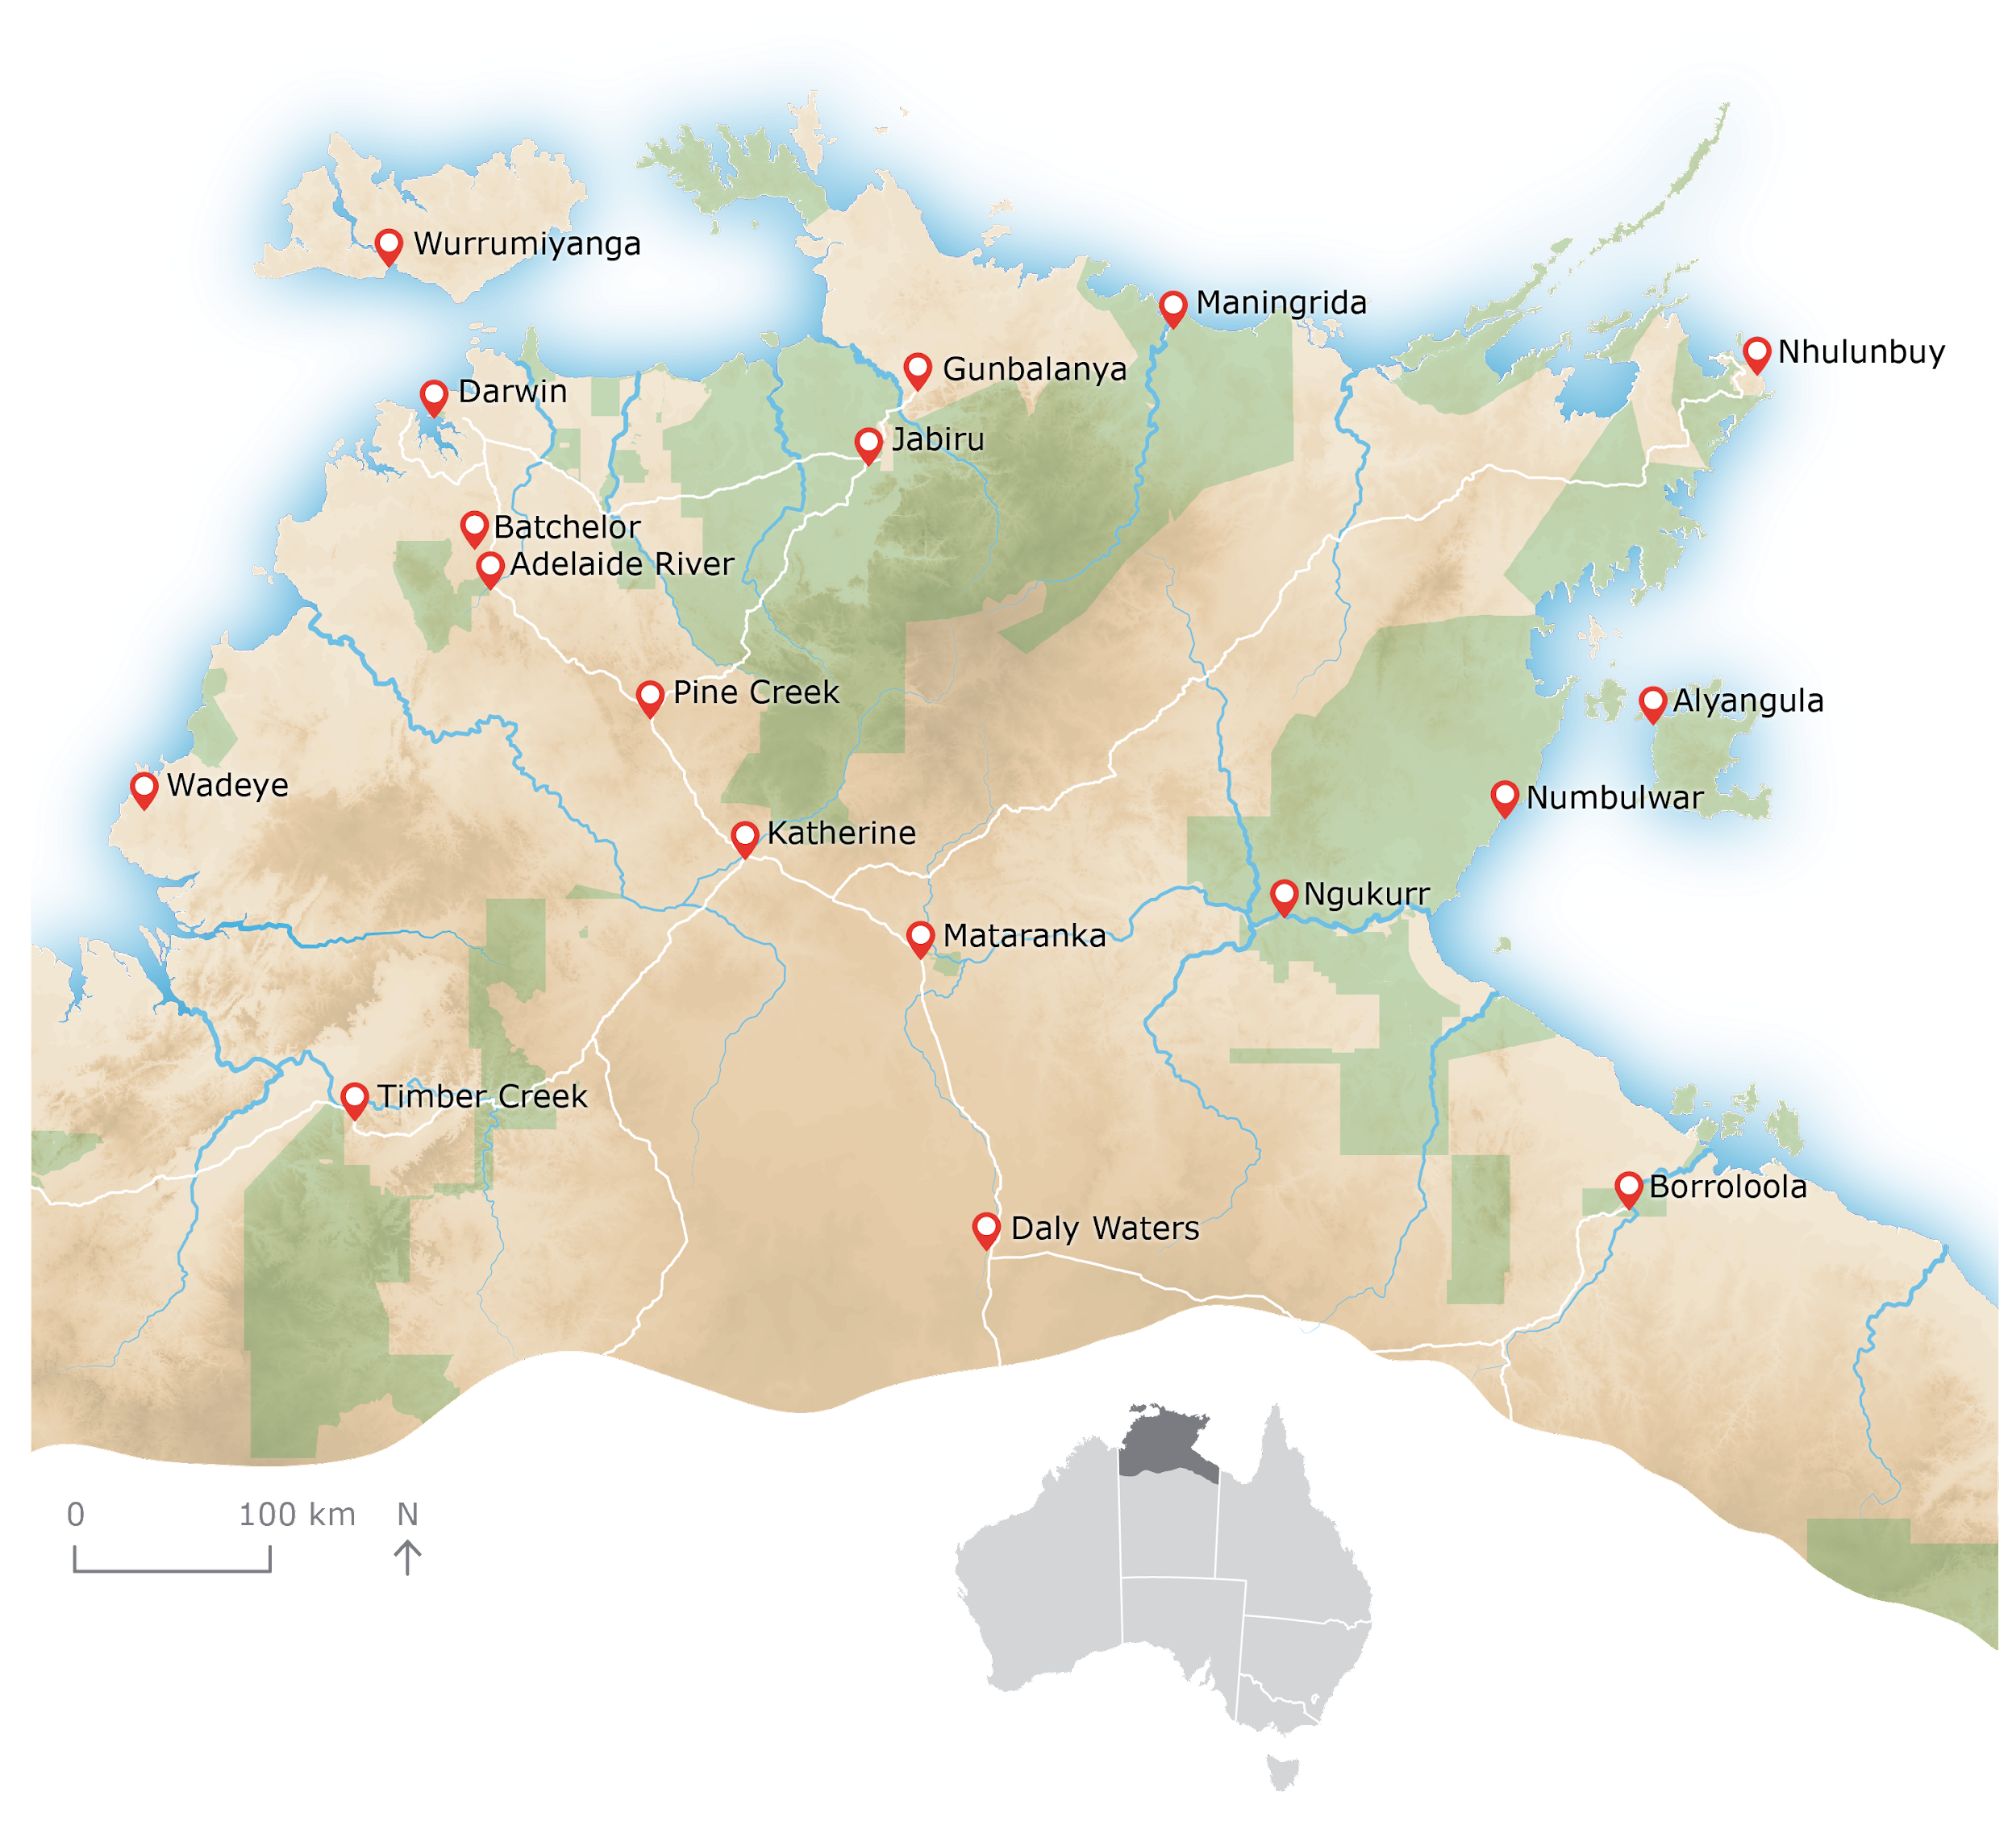

**The 'Top End’**

We cover over 42,000 km2 of the continental landmass, based on the ~600 mm rainfall gradient and covering the entire breadth of the Northern Territory (QLD border to WA border), and the Barkly Region to the northern tip of the continent, as well as the Tiwi Islands, Groote Eylandt, and all other offshore islands.

#### **What we do**

Some of our activities include: conducting research and monitoring programs, running capacity-building initiatives, advocating for birds or their habitats under threat, sharing knowledge and raising awareness among community members through community events, and forming collaborative partnerships with groups and Indigenous owners that manage the land on which birds belong. We are very focused on conservation science activities, monitoring shorebirds in Darwin Harbour through monthly counts is a key activity for our volunteers.

**Secretary**

BirdLife Australia Members with a strong interest in the future of the organisation can become involved by serving as Secretary of the BirdLife Top End Committee.

Network groups like BirdLife Top End work closely with the national organisation to achieve long-term systemic change. The Secretary is a key administrative officer of the Network group, a crucial link between Members and the Committee and is often the first point of contact for people seeking information or details about activities.

**The Secretary is expected to:**

* Ensure compliance with the Constitution of
* BirdLife Australia;
* Understand and ensure compliance with
* Birdlife Australia governance, policies and procedures;
* Be accountable to the BirdLife Australia CEO and Members;
* Ensure due process is followed;
* Usually acts as the first point of contact to Members and volunteers (e.g. for emails to
* networkname@birdlife.org.au);
* Schedule and organise meetings, including AGMs;
* Prepare meeting agendas, working with the Chair;
* Send out papers for the meeting to the Committee;
* Manage the process of the meeting (e.g. breaks, clarifications, timing);
* Securely store minutes, reports and records of the group’s activities;
* Maintain accurate records of the group’s attendance, a summary of discussions, decisions and actions in the minutes of the meeting; and
* Circulate minutes after the meeting

Please contact Brittany at [topend@birdlife.org.au](mailto:topend@birdlife.org.au) if you would like more information, or to apply for the role. If you would like to apply for the role, please include a short paragraph about yourself and your background in relation to the role.