
BirdLife Australia Indigenous Grant for Bird Research and Conservation
How-To Guide and Frequently Asked Questions

Contents
Introduction 2
Step 1. Eligibility 2
Step 1. (cont.) Checklist 3
Step 1. (cont.) Applicant Details 3
Step 2. Project Information 6
Step 3. Strategic Alignment 7
Step 4. Budget 9
Step 4 (cont.) Risk Management 10
Step 4. (cont.) File upload 11
Step 5. Applicant Signature 12
Frequently Asked Questions 14
1. How much can I apply for? 14
2. How do I know if my project is eligible? 14
3. How do I apply? 14
4. What do I do if I am not sure which stream my project fits into? 14
5. What are the timelines once applications close? 14
6. Can I apply after the closing date? 14
7. My project has already commenced, can I apply? 14
8. I have a project and want to speak to a BirdLife staff member to ensure my project aligns with their program, location or strategy. How do I know who to contact? 14
9. What types of risks should I put into my Risk Matrix? 14
11. What if I have another question? 14

Introduction
This document has been developed to assist you to complete your BirdLife Australia Indigenous Grant for Bird Research and Conservation application.

It will explain step-by-step with screen shots and include Frequently Asked Questions at the end.

Step 1. Eligibility

Check your eligibility. This can be found in the ‘Assessment Criteria’ section but is also listed at the start of the application form. Read this carefully, it may have changed from previous years.

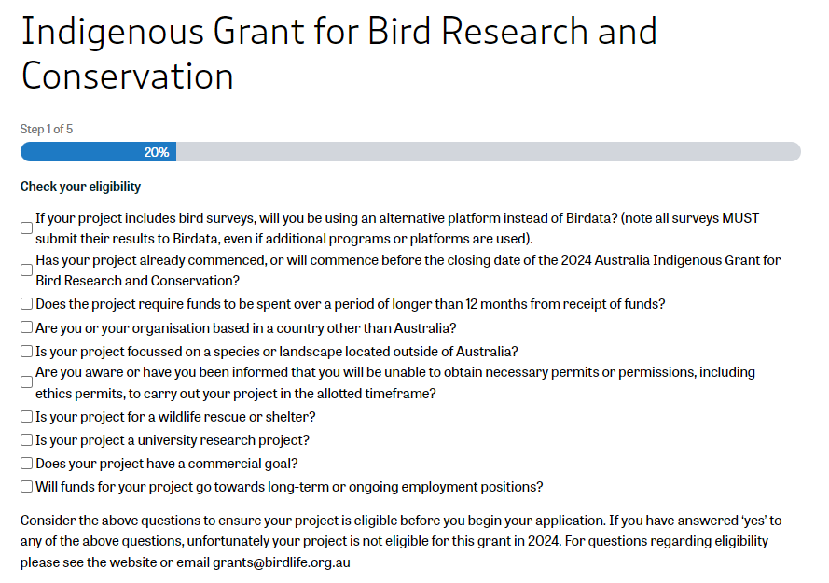

Step 1. (cont.) Checklist

Ensure you have checked each of the items.
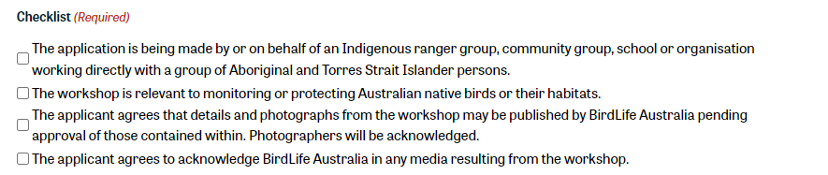

Step 1. (cont.) Applicant Details

Provide your details.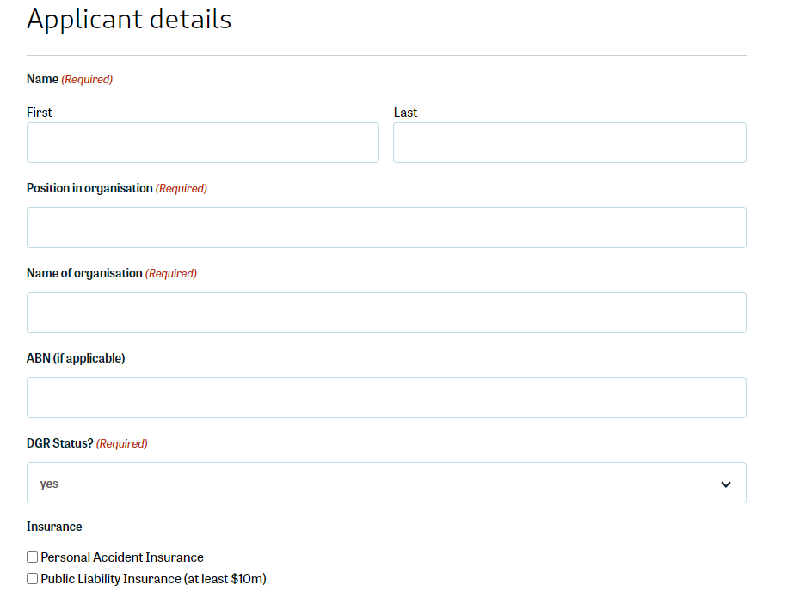
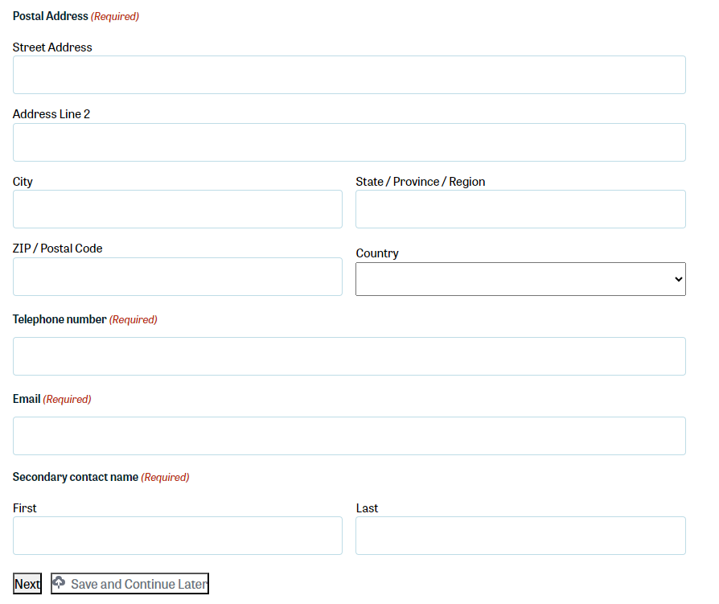

At the bottom of this section, you will see the buttons ‘Next’ and ‘Save and Continue Later’ (and ‘Previous’ once you have moved on to the following steps).
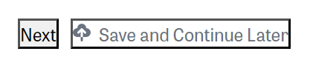
If you click ‘Save and Continue Later’ it will refresh the page. Scroll down and you will see this message with a link:
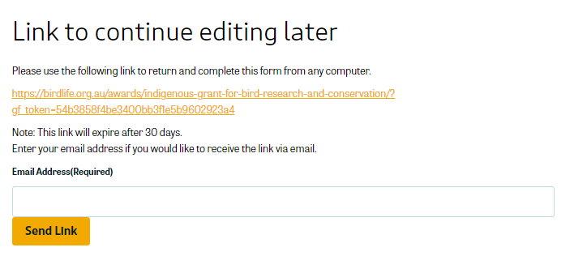

We strongly encourage you to save the link and send the link to your email address so that you don’t lose it. Each time edit your application and wish to return to it later, click the ‘Save and Continue Later’ to ensure your work is saved and you have an up-to-date link.

This is particularly helpful if you wish to work on your application in a Word or other document and then transfer the content into the application form once it has been written.

Step 2. Project Information

Provide your project’s title and a description of the project. Cover off how it addresses the assessment criteria for your stream (consider the prompts in the text box!).
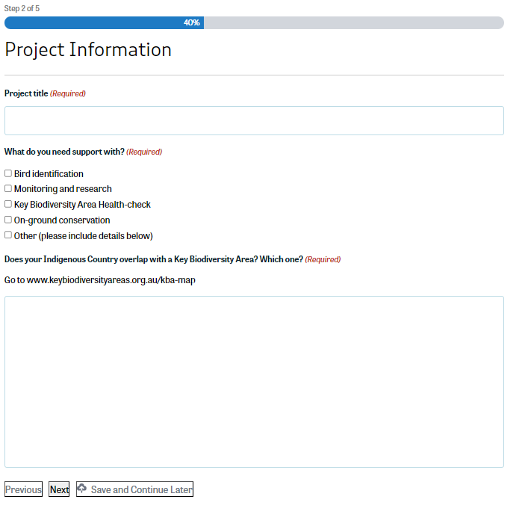

Step 3. Strategic Alignment
Continue with providing details of your project. Read the description carefully and take into account the explanation of what the question is asking. As before, in some of the text boxes there are reminders of the key and priority project assessment criteria mapped to this question so consider how your project may link to them.

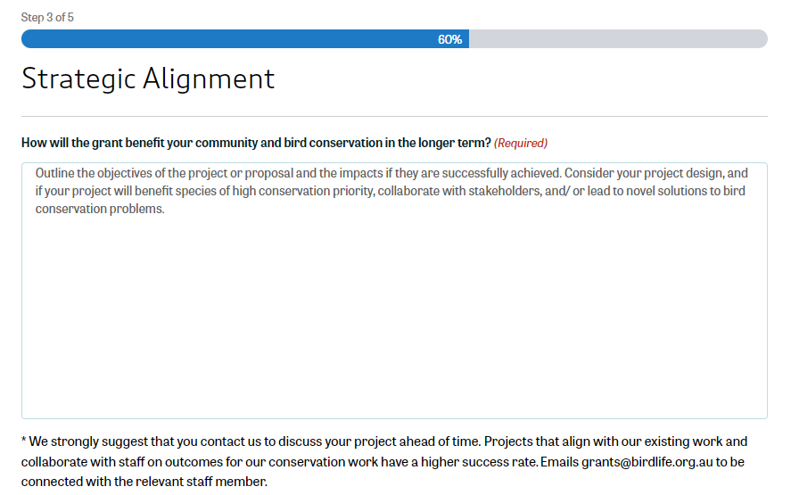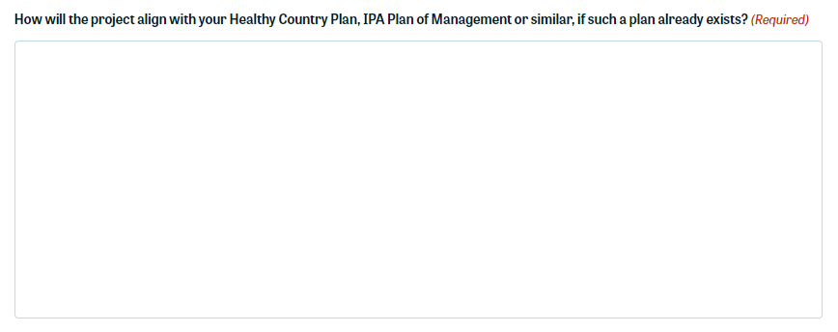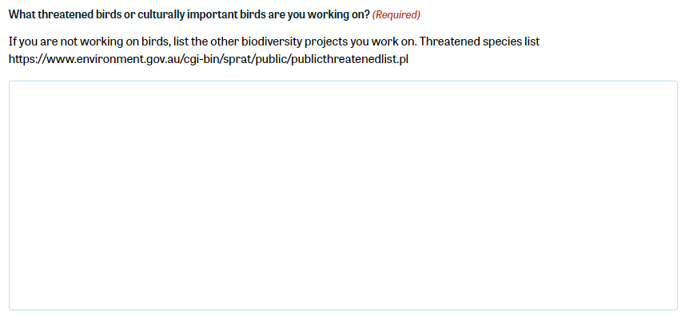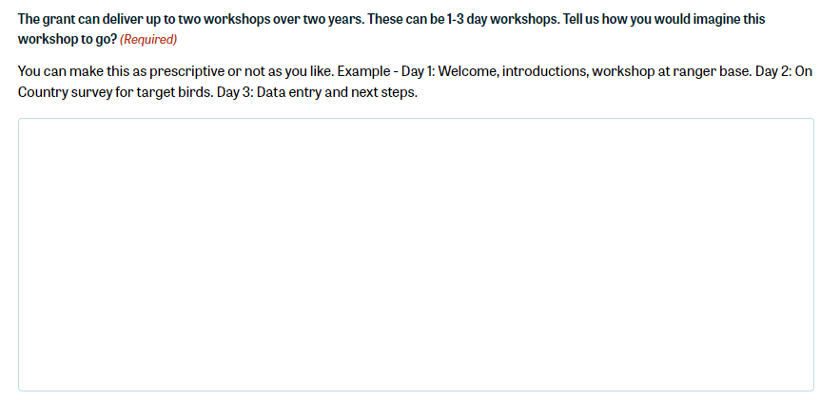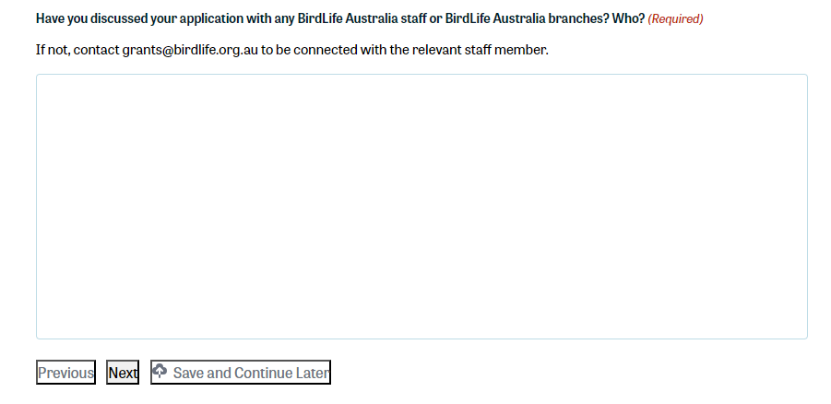

Step 4. Budget
Complete your budget. Include:

- Budget breakdown column: explanation of the item.
- $ Budget (not including GST): the amount requested of that item (numerals only)
- Timeframe: how long that item will take to complete

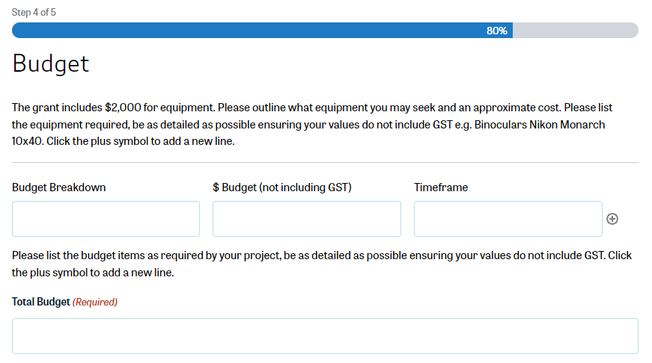

To add more items, click the circle with the + symbol to the right of the ‘Timeframe’ column to add a new line.
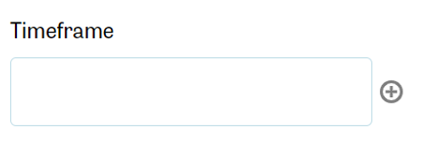

Once this section is complete, write the total amount you are requesting in the Total Budget line. Ensure this matches with the amounts listed in the budget breakdown.
!Quick tip! Don’t request $2,000 just because that is the maximum you can request. Note in the assessment criteria for both streams the requirement: Demonstrate cost-effectiveness. Uploading quotes in the attachment section (bottom of step 4) will assist in demonstrating your cost effective planning.

Step 4 (cont.) Risk Management

Complete the Risk Management section. Similarly to the budget, you can add additional lines by clicking the circle with the + symbol in it to the right of the columns.

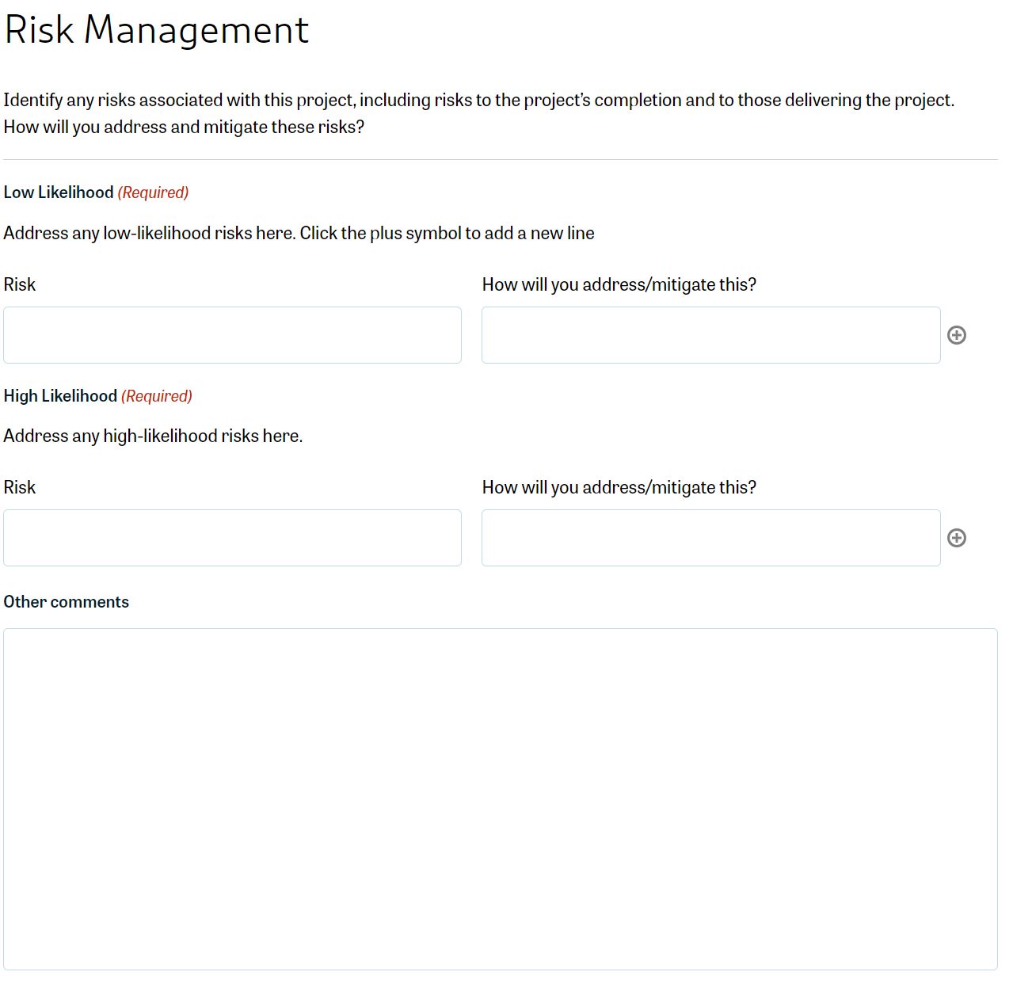

!Quick tip! Consider all possible risks to your project, not just OHS. It is better to identify more risks than less, as the assessment panel will be looking at how thoroughly you have considered risks to your projects success and planned on how to mitigate them.

Step 4. (cont.) File upload

Upload any supporting documents for your project. This might include documents such as letters of support, permits, quotes, or maps.

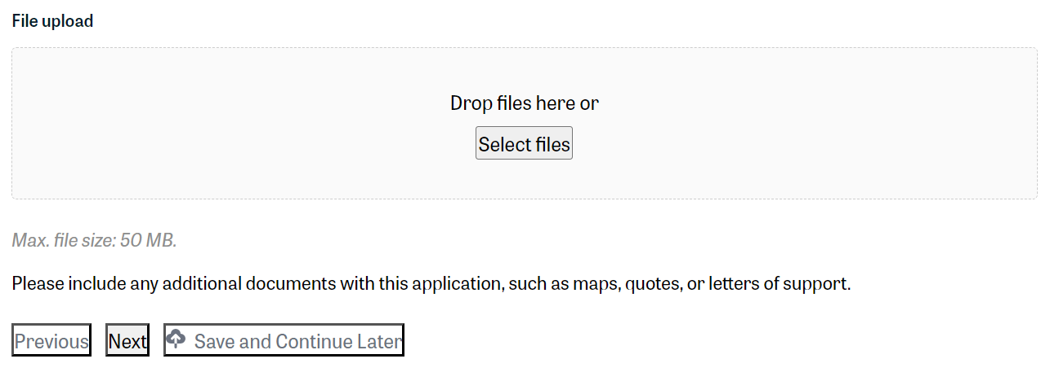

Step 5. Applicant Signature
The final step! Acknowledge the declaration and sign it off.
When you are sure you have completed your application, click ‘Submit’.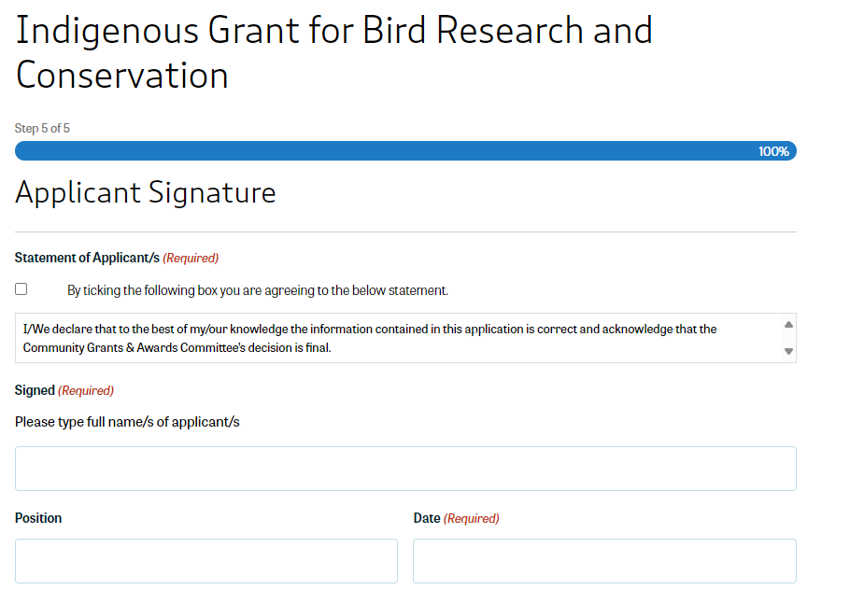 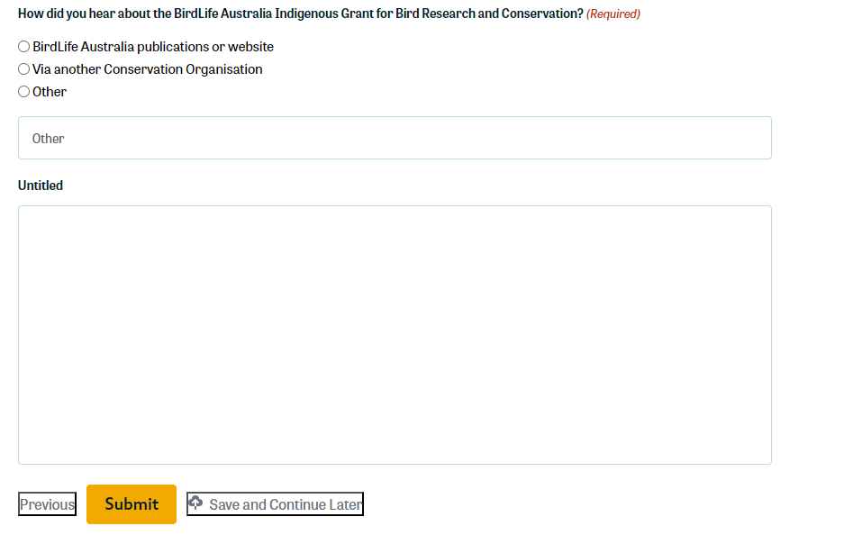

You will receive a refreshed screen and notification stating: Thanks for your application! We will be in touch with you shortly.

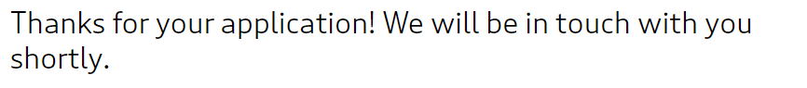
You will also receive an email acknowledging receipt of your application.
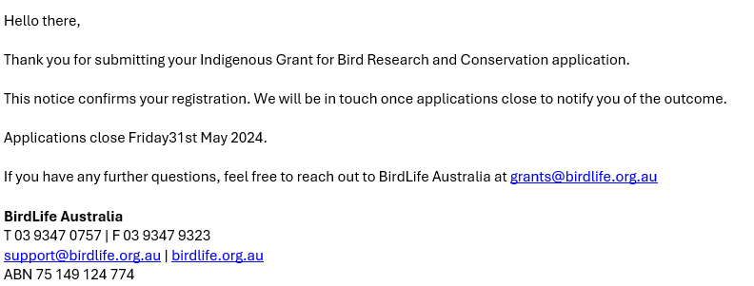

If you do not receive this email within 24 hours, first check your junk or spam folder. If it is not in this folder, contact grants@birdlife.org.au to confirm that your application has been received.

Frequently Asked Questions

How much can I apply for?
You can apply for a maximum of $2,000. Note that assessors will be considering cost effectiveness in their assessment, so ensure you are providing a realistic budget. Upload quotes where possible as evidence.

How do I know if my project is eligible?
Check the eligibility criteria listed on the webpage and in step 1 of the application form.

How do I apply?
Scroll down to the bottom of the webpage. The application form begins here.

What do I do if I am not sure which stream my project fits into?
Contact grants@birdlife.org.au and a member of our team will discuss your project with you.

What are the timelines once applications close?
The application assessments and assessor panel will be completed over June.
Results will be announced in early July, usually NAIDOC week.

Can I apply after the closing date?
Late applications may be accepted with prior notice.

My project has already commenced, can I apply?
No, funding will not be given to projects retrospectively.

I have a project and want to speak to a BirdLife staff member to ensure my project aligns with their program, location or strategy. How do I know who to contact?
Good decision! Contact grants@birdlife.org.au and our team will connect you with the appropriate BirdLife Australia staff member.

What types of risks should I put into my Risk Matrix?
Not just OHS (though this should be a consideration, particularly if you will be doing fieldwork). Consider the risks to your project succeeding. What happens if you don’t receive a permit in time? What will you do if your venue cancels? What happens if there is extreme weather forecasted on your activity day? What if your equipment doesn’t arrive in time?

We cannot emphasise strongly enough how important it is to NOT write ‘no risks’ in this section!

- I’ve just realised that I need to edit my application! What do I do?
Contact grants@birdlife.org.au and a member of our team will be in touch.

What if I have another question?
Contact grants@birdlife.org.au and a member of our team will be in touch.

Prepared April 2024, revised May 2026

